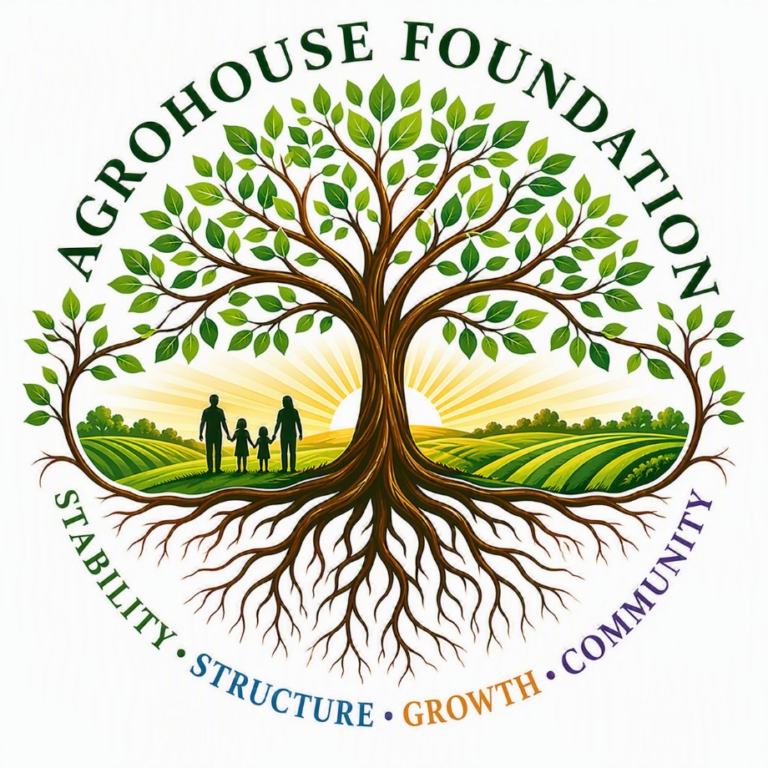
AgroHouse Foundation™
Board Member Onboarding Packet
Prepared for:
Christopher Pearce
Date of Appointment: __________________
© 2026 AgroHouse Foundation™. All Rights Reserved.

Welcome Letter
Date: ______________________________
Dear Christopher,
You are stepping into a foundational leadership role within AgroHouse Foundation™.
As a Board Member, your role is to provide oversight, guidance, and perspective to help ensure the organization develops in a way that remains structured, sustainable, and aligned with its mission.
Your experience and involvement within the community provide valuable insight into how the organization is understood, supported, and connected to those it serves.
This role is focused on governance and long-term direction, not day-to-day operations. I appreciate your willingness to be part of building this foundation and helping shape its impact within the community.
Sincerely,
Maggie Baty
Founder, AgroHouse Foundation™

Contents
1. Welcome Letter
2. Mission & Vision Overview
3. Bylaws
4. Conflict of Interest Policy
5. Board Member Agreement
6. Board Role Summary
7. Acknowledgment & Signature Page

Mission & Vision Overview

Mission
AgroHouse Foundation™ exists to develop sustainable food production systems, workforce development pathways, and vocational opportunities that support community stability and long-term independence.

Vision
AgroHouse Foundation™ is building an integrated system where:
- Food is produced locally and sustainably
- Outreach is stable and consistent
- Individuals have opportunities to learn, work, and grow
- Communities are supported through structured, long-term solutions

Core Foundation Principle
AgroHouse Foundation™ is not a single program—it is an integrated system where each component builds upon and strengthens the others over time.

Core Model
AgroHouse Foundation™ operates through four integrated components that are developed in phases but function together as one system.
1. Outreach Stabilization
Purpose: Provide immediate support to stabilize existing outreach while long-term systems are developed.
Functions:
- Short-term food supply support
- Gap coverage through grants and partnerships
- Support of existing distribution efforts
Role in the System: Acts as the foundational layer, ensuring consistent service while the system is being built.
2. Agricultural Production & Food System
Purpose: Develop a reliable, local food production system that supports outreach and expands community food access.
Functions:
- Crop production
- Livestock development
- Integrated farm operations
Food Distribution Channels:
- Outreach programs
- Farm stand
- Local public schools
Role in the System: Transitions the model from dependence on outside supply to sustainable, internal production.
3. Workforce Development System
Purpose: Create structured pathways for individuals to develop skills, build responsibility, and participate in meaningful work.
Adult Workforce Development:
- Skill-building opportunities
- Operational participation
- Work readiness
Teen Education & Workforce:
- Early exposure to agriculture and systems
- Structured learning environment
- Job readiness foundation
Role in the System: Creates movement from Support → Participation → Capability.
4. AgroHouse™ Vocational Housing System
Purpose: Provide structured housing integrated with workforce participation and long-term system engagement.
Functions:
- Vocational housing connected to program participation
- Integrated training and living environment
- Expanded system capacity
System Contributions:
- Additional food production
- Increased workforce involvement
- Reinforcement of structure and responsibility
Role in the System: Creates a fully integrated living and working system that supports long-term growth and sustainability.

Full System Integration
Outreach Stabilization → Agricultural Production System → Workforce Development → Vocational Housing Expansion → Fully Integrated Community Support System

System Truth
Each component strengthens and expands the system. Nothing replaces what came before—every phase builds on the last to create long-term sustainability.

Community Partnership Model
AgroHouse Foundation™ works alongside existing organizations, not in place of them.
Example Structure:
- Community partners → Provide outreach and connection
- AgroHouse Foundation → Provides structure, systems, and long-term support

Core Values
- Stability – Building consistent and reliable systems
- Structure – Creating clear, repeatable operations
- Sustainability – Focusing on long-term solutions
- Opportunity – Providing pathways for growth and development
- Respect – Supporting individuals without pressure or obligation

What Success Looks Like
- Outreach operates consistently and without strain
- Food supply becomes stable and locally supported
- Individuals move into participation and skill development
- Workforce pathways become established
- Vocational housing supports long-term growth
- The system sustains itself through integration

Core Differentiator
Without AgroHouse:
- Inconsistent supply
- Reactive operations
- Limited growth
With AgroHouse Foundation™:
- Stable food systems
- Structured operations
- Workforce pathways
- Scalable and sustainable model

Foundation Intent
AgroHouse Foundation™ is designed to:
- Strengthen existing outreach
- Build long-term food production systems
- Develop workforce capacity
- Create structured, sustainable solutions
- Support communities through an integrated system
© 2026 AgroHouse Foundation™. All Rights Reserved. This mission and system model is the intellectual property of AgroHouse Foundation™ and may not be reproduced without permission.

Bylaws

Article I — Name and Purpose
Section 1. Name
The name of this organization shall be: AgroHouse Foundation™
Section 2. Purpose
AgroHouse Foundation™ is organized exclusively for charitable, educational, and nonprofit purposes under Section 501(c)(3) of the Internal Revenue Code.
The organization exists to:
- Provide food assistance through sustainable agricultural systems
- Develop structured workforce training programs
- Offer youth education in agriculture and mechanical skills
- Build long-term community stability systems
- Develop transitional housing through the AgroHouse™ Model
- Support individuals and families experiencing food insecurity

Article II — Board of Directors
Section 1. Authority
The Board of Directors shall govern the affairs of the organization and ensure alignment with its mission, legal compliance, and financial responsibility.
Section 2. Composition
The Board shall consist of no fewer than three (3) members.
Initial board structure may include:
- Founder / Executive Director
- Community / Outreach Representative
- Education or Program Representative
- Fleet & Mechanical Systems Lead
- Additional members as needed
Section 3. Terms
Board members shall serve two (2) year terms and may be reappointed.
Section 4. Duties
Board members shall:
- Provide oversight and governance
- Approve major decisions and policies
- Ensure responsible use of funds
- Support the mission and programs
- Maintain compliance with nonprofit laws
Section 5. Meetings
- The Board shall meet at least once annually
- Additional meetings may be held as needed
Section 6. Quorum
A majority of the Board shall constitute a quorum.
Section 7. Voting
Each board member shall have one vote. Decisions are made by majority vote unless otherwise specified.
Section 8. Removal
A board member may be removed by majority vote if:
- Duties are not fulfilled
- Actions conflict with the mission
- Legal or ethical violations occur

Article III — Officers
Section 1. Officers
The organization may include:
- President (Founder / Executive Director)
- Secretary
- Treasurer
Section 2. President / Executive Director
The President shall:
- Oversee daily operations
- Implement board decisions
- Lead organizational strategy and development

Article IV — Compensation
Section 1. Board Service
Board members shall not receive compensation for board service.
Section 2. Operational Roles
Board members may receive compensation for separate operational roles, provided that:
- Compensation is reasonable
- Compensation is approved by the Board
- The individual does not vote on their own compensation

Article V — Assets and Property
Section 1. Ownership
All organizational assets—including land, vehicles, equipment, and facilities—are owned by AgroHouse Foundation™.
Section 2. Use Restrictions
Assets:
- Must be used for mission-related purposes only
- Shall not be used for personal benefit or private gain

Article VI — Conflict of Interest
The organization shall maintain a Conflict of Interest Policy to ensure transparency and ethical decision-making.

Article VII — Dissolution
Upon dissolution, all assets shall be distributed to another 501(c)(3) organization with a similar mission.

Article VIII — Amendments
These bylaws may be amended by majority vote of the Board of Directors.
© 2026 AgroHouse Foundation™. All Rights Reserved.

Conflict of Interest Policy

Article I — Purpose
The purpose of this policy is to protect AgroHouse Foundation™ from conflicts between personal interests and organizational duties.

Article II — Definition of Conflict
A conflict of interest exists when a person has:
- A financial interest
- A personal benefit
- Or any relationship that could influence decision-making

Article III — Covered Persons
This policy applies to:
- Board members
- Officers
- Staff in leadership roles

Article IV — Duty to Disclose
Each covered person must disclose any actual or potential conflict of interest.

Article V — Procedures
1. Disclosure
The individual must disclose the conflict to the Board.
2. Recusal
The individual must:
- Not participate in discussion when necessary
- Not vote on the matter
3. Determination
The Board shall determine:
- Whether a conflict exists
- Whether the decision is fair and reasonable

Article VI — Compensation Conflicts
If a board member is compensated:
- The compensation must be disclosed
- The individual cannot vote on it
- The Board must determine that it is reasonable

Article VII — Records
Meeting records must include:
- Disclosure of conflicts
- Actions taken
- Final decisions

Article VIII — Annual Statement
Each board member shall annually confirm:
- Understanding of this policy
- Agreement to comply
- Commitment to disclose conflicts

Article IX — Violations
If a conflict is not disclosed:
- The Board may investigate
- Appropriate corrective action may occur
© 2026 AgroHouse Foundation™. All Rights Reserved.

Board Member Agreement

Board Member Information
Name: Christopher Pearce
Board Position / Title: Board Member
Date of Appointment: ______________________________

Purpose of This Agreement
This agreement outlines the roles, responsibilities, and expectations of Christopher Pearce as a Board Member of AgroHouse Foundation™.
This document ensures clear governance, accountability, and alignment with the organization's mission and long-term development.

Organization Overview
AgroHouse Foundation™ is an integrated system designed to support community stability through:
- Sustainable food production
- Workforce development
- Structured community support
- Vocational housing
Each component builds upon the previous to create a long-term, sustainable system.

Board Member Role
As a Board Member, Christopher Pearce agrees to:
- Support the mission and purpose of AgroHouse Foundation™
- Participate in board discussions and decision-making
- Provide oversight and strategic guidance
- Act in the best interest of the organization

Board Contribution
Christopher Pearce contributes to the Board through:
- Insight into community engagement and needs
- Perspective on communication and public understanding
- Input on how the organization is perceived and supported within the community
- Support in ensuring alignment between the organization and those it serves
This contribution is advisory in nature and does not constitute operational authority within the organization.

Fiduciary Duties
Christopher Pearce agrees to uphold the following:
Duty of Care
Act with informed judgment, diligence, and reasonable care
Duty of Loyalty
Act in the best interest of the organization above personal interest
Duty of Obedience
Ensure alignment with mission and compliance with all applicable laws

Governance Responsibilities
Board Members are responsible for:
- Providing strategic oversight
- Participating in decision-making
- Supporting long-term planning and sustainability
- Ensuring responsible and ethical organizational conduct

Role Clarification (Important)
This Board role is strictly governance-based and separate from operational functions.
Board Role Includes:
- Oversight
- Strategic guidance
- Decision-making
Any operational responsibilities are defined under a separate role agreement (if applicable).

Compensation
- Board service is voluntary
- No compensation is provided for Board duties
Future Consideration:
If Christopher Pearce serves in a separate operational role, compensation must be:
- Reasonable
- Approved by the Board
- In compliance with nonprofit regulations
- Not voted on by the individual receiving compensation

Conflict of Interest
Christopher Pearce agrees to:
- Disclose any potential or actual conflicts of interest
- Refrain from participating in decisions where a conflict exists
- Act with transparency and integrity

Confidentiality
Christopher Pearce agrees to:
- Maintain confidentiality of internal organizational matters
- Protect discussions, planning, and sensitive information

Compliance
Christopher Pearce agrees to support:
- 501(c)(3) compliance standards
- Ethical governance practices
- Organizational integrity

Term of Agreement
This agreement remains in effect until:
- Resignation
- Removal by Board decision
- Amendment or replacement of this agreement

Removal
A Board Member may be removed by majority vote if:
- Responsibilities are not fulfilled
- Actions conflict with the mission
- Ethical or legal violations occur

Acknowledgement
By signing below, both parties confirm understanding and agreement to the terms outlined in this document.

Signatures
Christopher Pearce
Signature: _____________________________________________
Date: ______________________________
Maggie Baty
Authorized Representative, Founder
Signature: _____________________________________________
Date: ______________________________

Board Role Summary
Christopher Pearce
Board Member

Primary Responsibility
Provide governance, oversight, and strategic input in support of the mission and long-term development of AgroHouse Foundation™.

Core Responsibilities
- Participate in Board-level discussions and decisions
- Provide insight based on experience
- Support alignment between the organization and community needs
- Offer perspective on communication and public understanding
- Contribute to the organization's long-term stability and growth

Role Clarification
This role is governance-based and does not include day-to-day operational responsibilities.

Acknowledgment & Signature Page
Date: ______________________________

Board Member Information
Name: Christopher Pearce
Position: Board Member

Acknowledgement
I, Christopher Pearce, acknowledge that I have received, reviewed, and understand the following governing documents of AgroHouse Foundation™:
- Bylaws
- Conflict of Interest Policy
- Board Member Agreement

Statement of Agreement
By signing below, I agree to:
- Act in accordance with the mission of AgroHouse Foundation™
- Comply with the organization's Bylaws
- Adhere to the Conflict of Interest Policy
- Fulfill my responsibilities as a Board Member in good faith
- Act in the best interest of the organization at all times

Conflict of Interest Confirmation
I understand that:
- I am required to disclose any potential conflicts of interest
- I will not participate in decisions where I have a personal or financial interest
- I will recuse myself from decisions involving my compensation or personal benefit

Confidentiality
I agree to maintain the confidentiality of internal organizational information and not disclose sensitive information without authorization.

Signature
Christopher Pearce
Board Member
Signature: _____________________________________________
Date: ______________________________
Maggie Baty
Founder, AgroHouse Foundation™
Signature: _____________________________________________
Date: ______________________________

